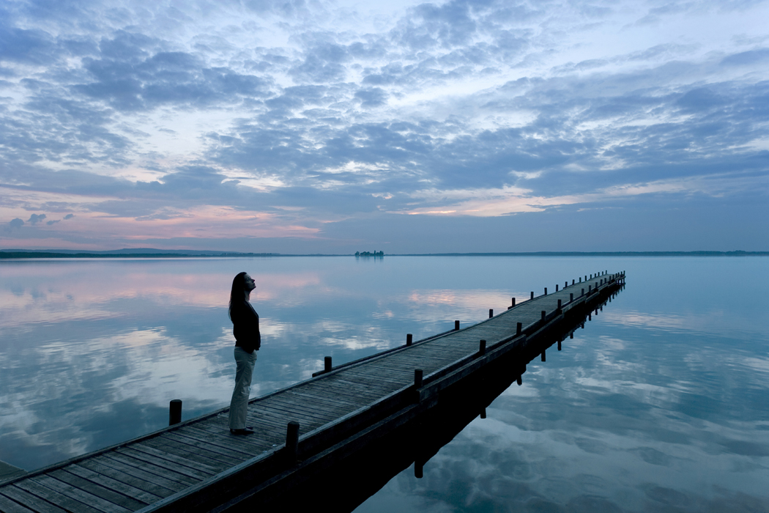
Complete your meditation expressing gratitude. Then have a wonderful rest of the day or evening.
Date:
Today I am grateful for:

