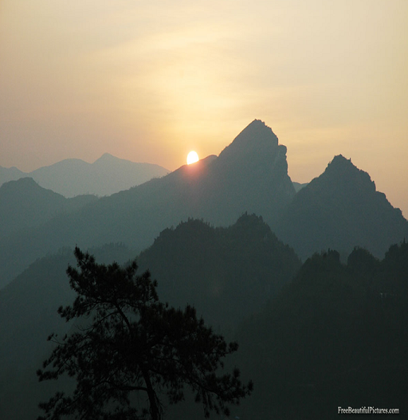
Gratitude: the perfect starts to a beautiful new day.
Today I am grateful for:

