Regardless of how the day has gone, end it with gratitude and rest well.
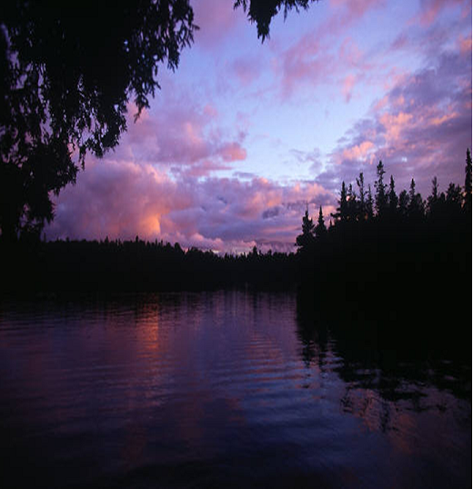
Today I am grateful for:

