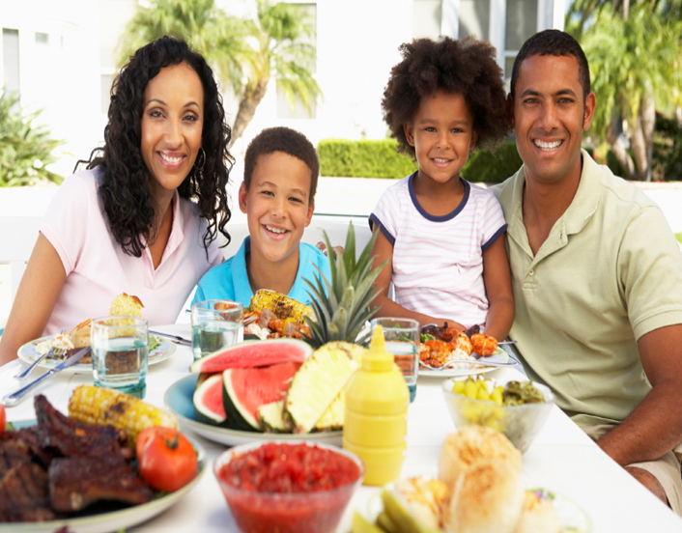
Happy family together at dinner, so much to be grateful for!
Today I am grateful for:

