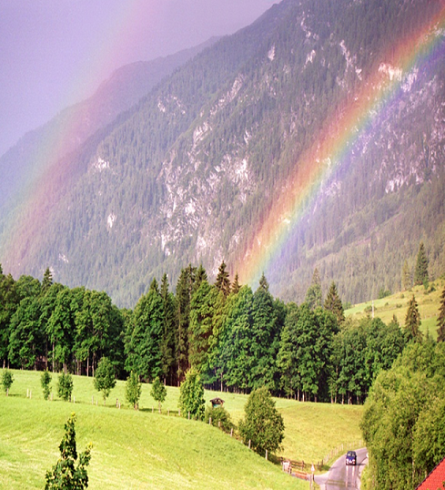
Have a beautiful rainbow day. Express your gratitude.
Today I am grateful for:

